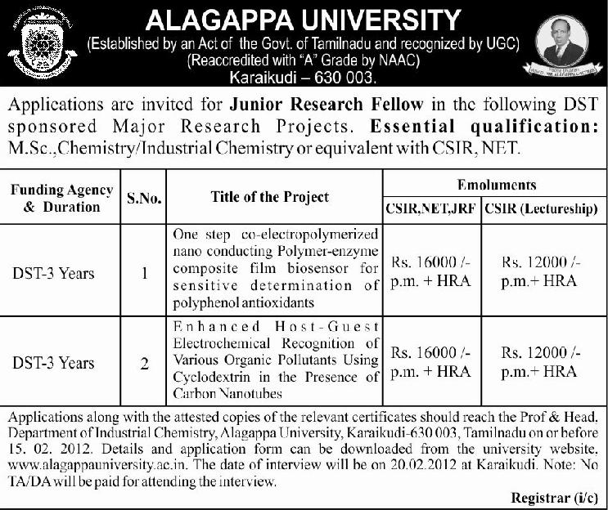


ALAGAPPA UNIVERSITY
(Reaccredited with ‘A’ Grade by NAAC)
School of Chemical Sciences
Department of Industrial Chemistry
(DST FIST, PURSE and UGC SAP Assisted Department)
Karaikudi - 630 003.

JUNIOR RESEARCH FELLOW RECRUITMENT -2012
APPLICATION FORM

Post : JRF

Project applied for : Please tick the column(√)
Project 1 |  | Project 2
Name of the applicant :

ATTACH RECENT
PASSPORT SIZE
PHOTOGRAPH HERE

Date of birth & Age :
Gender :
Marital status :
Nationality :
Languages known :
Educational qualification :
Percentage of Marks in M.Sc :
Percentage of Marks in M.Phil :
CSIR NET qualified : Yes/No (Stride out in relevant item)
CSIR lectureship qualified : Yes/No (Stide out in relevant item)
Research experience : ---- Years (Details must be attached)
Research papers published : ---- (Details must be attached)
Research articles presented in
Conference/Seminar : ---- (Details must be attached)
Permanent address :

Contact details :

E-mail address :

Home : Mobile :

I hereby declare that all the informations given above are true to the best of my knowledge.

Date :

Place : Signature of the Applicant

